Newsletter  
Term 3 Week 4 

August 18 2021

# What's going on?

| 18 August | SCHOOL CLOSED COVID LEVEL 4 |
| --- | --- |
| 25 August | SCHOOL REOPENS  This may be subject to change |
| 25 August | Rodney College Open Evening 4:30-5:30 pm  HERO parent education 3-4 pm  BOT meeting 7 pm |
| 26 August | Parent forum 6-7 pm |
| 27 August | Daffodil Day |
| 30 August | TOD-school closed |
| 1 Sept | Yr 7/8 Tech |
| 2 Sept | Maori Consultation Forum 6-7 pm |
| 3 Sept | RRS Netball/Touch day Year 4-8 |
| 7 Sept | Parent Education afternoon 3-5 pm on Reading |
| 10 Sept | School speech competition |
| 14 Sept | Rodney College interviews |
| 17 Sept | RRS Speech Competition |
| 27 Sept-  1 Oct | PRODUCTION WEEK |
| 28/30 Aug | PRODUCTION PERFORMANCES |

# 

# Birthdays

## 

Mayan Kingi & Charlotte Clayden

## Mrs Neel’s Musings

## 

## Dear families & whanau

Kia ora, kia orana, talofa, malo e lele, kon’nichiwa, hello

WELL….. HERE WE GO AGAIN!!!!

Who knew that the whole country would be in Level 4 Lockdown from today. Although it is a huge inconvenience for a lot of people, we have to be realistic. I don’t want the same statistics that Australia has at the moment with cases and deaths, so we all need to bite the bullet & be sensible. Tomarata School is already suffering with sick children & staff with the nasty tummy bug & cold that is going around. I’ve woken up with a full on head cold myself, so this is a good time for everyone to rest, recuperate & recharge. Consider it a mid term break!

We have decided that online learning will officially start next week. Some teachers have already put activities up on SEESAW so please look & do what is manageable for you & your family. I am in negotiation with the Ministry to get hard packs too, so will see how that goes. In the meantime stay home & stay safe!

Production plans & rehearsals are rolling along, although good old COVID is putting a hitch in that too. Cross fingers that we don’t need to reschedule! Thanks to the few people who are offering their time, skills & effort. Time will pass quickly, so every day is important.

I am going to start to include some aspects of our Tomarata Local Curriculum Plan in newsletters to help provide a clear understanding of learning at our school. Our curriculum is based on the New Zealand Curriculum, as well as our local environment. This allows us the flexibility to mould programmes to our school vision, culture & values. Please read the information under the Curriculum Plan heading , further in this newsletter.

Our parent education evening has been rescheduled due to being in Lockdown. It will now take place on 6 September. It will be a practical as well as discussion afternoon, & you will receive strategies to help your children with reading at home.

The children have started practising for the Rodney Rural Schools annual Touch/Netball day which is coming up soon. Many thanks to Miss McGuiness who is coaching netball, & Mrs Jackson who is coaching touch. We appreciate your time & effort with this.

You will probably have noticed that the children are beginning to talk about & work on their speeches for the school & RRS competitions. Lockdown will be the perfect opportunity for them to write & practise these.

Well that’s it from me. Hoping to see you all again next Wednesday!

*Wastewise wisdom:*

*Did you know that the cost of getting rid of our rubbish is increasing every year? Buy your fruit, vegetables & meat without tray packaging if you can. If enough people refuse to buy such food items in packaging, supermarkets will hopefully stop packaging them that way!*

[**principal@tomarata.school.nz**](mailto:principal@tomarata.school.nz)

__________________________________________________

# Our Vision

*Keeping class sizes manageable and adding extra support where it is needed helps everyone work on their goals in the best possible environment.*

At this point in time the class sizes at Tomarata School are below the average for typical New Zealand schools. We do not have the luxury of a huge staff, explaining why our classes are composite ( i.e. 2 year levels in the same class). We have 4 teacher aides at present ( Jo, Jane, Jen & Heather) who work with our children requiring extra support. Jo, Jen & Jane work specifically with children who have High Health Needs, & Jo covers the rest of the school. Every term we reassess where this support is most needed. We occasionally receive a small amount of funding from the Ministry & sometimes other outside agencies to prop up our limited budget. The teachers also assess the data from testing to work out which children require added support in class for the core subject areas.

[**Tomarata School Shared Vision can be read in full here.**](https://docs.google.com/document/d/1XODboho0oPxNrrgrYJLnFEDEXMDfTnPQM5TEWitL2wk/edit?usp=sharing)

# Reminders

Remember that you can access the newsletter on HERO now too. Please take the time to log on to HERO & see what it can do for you.

Year ⅞ students- Blue Light Ventures is holding their annual Rainbow’s End Fun Day again. The children have already bought home a newsletter with this information. Payment can be made at the office when we open again next Wednesday.

I will have to wait to be contacted by Rodney College about their transition to High School visits that were supposed to start today. Further information will be relayed as I get it.

# PB4L Focus

[Tomarata School Behaviour Plan can be read here](https://drive.google.com/file/d/12XgEtYd8ZOOrOE3T_Z4Pi6A_nCeBv83t/view?usp=sharing)

# Shout outs

**Students**

Congratulations to the following students who earned the Values mascots at assembly on Monday.

Arley Baker for Growth; Payson Ecroyd for Respect; Lucas Davis for Ownership and Jack Clements for Working Together Harmoniously. Awesome effort guys!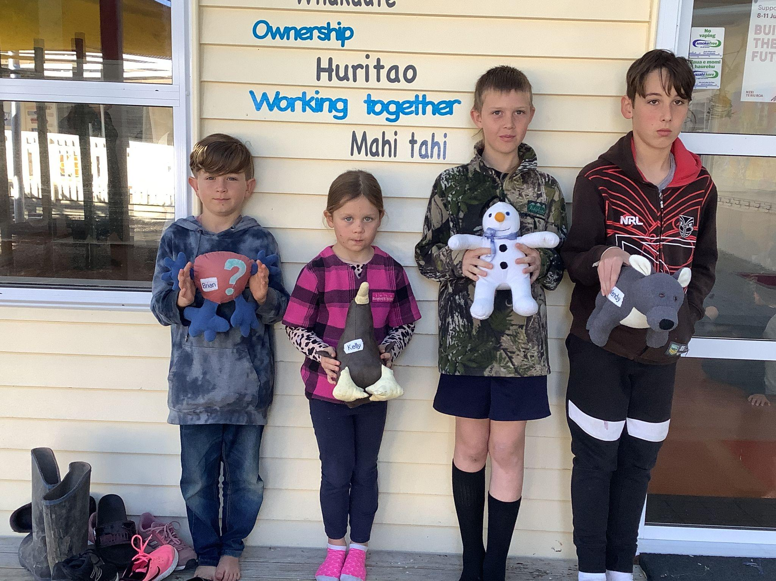

The Ecroyd family have had a successful week with Brock from Room 2 sharing his letter work.

Finally cool bananas to Mana Spiro who met my challenge of giving me the Maori word for Growth which is Tipu.

Community

Unfortunately we had a near miss outside school at pick up time on Monday. There are a number of parents parking in the wrong place, which then causes problems for our bus entering & leaving the bus pick up zone. One of our students ran behind the bus while it was reversing to get to a parent in a car. Luckily we had a number of people who saw what was going to happen & leapt into action. PLEASE PLEASE do NOT park near the bus zone. We will be placing large cones out to mark the no parking area as of next week, & ask that you respect them.

We are also going to change the car pick up area from the bus gate to the new gate by the pool for the reasons as below:.

1) It is more visible for parents, kids and teachers

2) The parking is easier and more out of the way of buses

3) The kids can wait in the gazebo if it’s raining

Many thanks to Anne Richards for her suggestion!

**PRODUCTION**

WE NEED A photographer for the nights. Do you have this expertise that you would be willing to share?

If this sounds like you please contact Mrs Neels at school.…it’ll be a blast!

# Parent Forum

Our next Parent Forum will be ( hopefully) on Thursday 26 August at 6 pm in the staffroom all are welcome. We will also be holding a Maori Whanau Consultation night on Thursday 2 September at 6 pm. We would like our Maori whanau to attend, as well as in other interested families, to discuss what Tikanga Maori could look like at Tomarata School.

Helping Hands Update

**To contact HH please email Erica Casey** helpinghands@tomarata.school.nz

# BOT Update

Our next Board meeting is (hopefully) on Wednesday the 25th August at 7 pm in the Boardroom. All are welcome.

**To contact the BOT please email**

**Jason Kerrisk** [boardchair@tomarata.school.nz](mailto:boardchair@tomarata.school.nz)

HERO

For information about HERO, including how to log in go to

<http://go.linc-ed.com/>

Community Notices.

**Tomarata Playcentre**

619 School Road, RD 4, Wellsford

[tomarata@Playcentre.org.nz](mailto:tomarata@Playcentre.org.nz)

09 423 9074 Tuesday, Thursday & Fridays 9.30-12pm

Travelwise

Last Friday we had the Travelwise people visit the school to teach the children about Truck safety. We have a number of large, fast trucks passing the school every day, so it is paramount that we teach our children how to be safe around them. Here are some photos of the day.

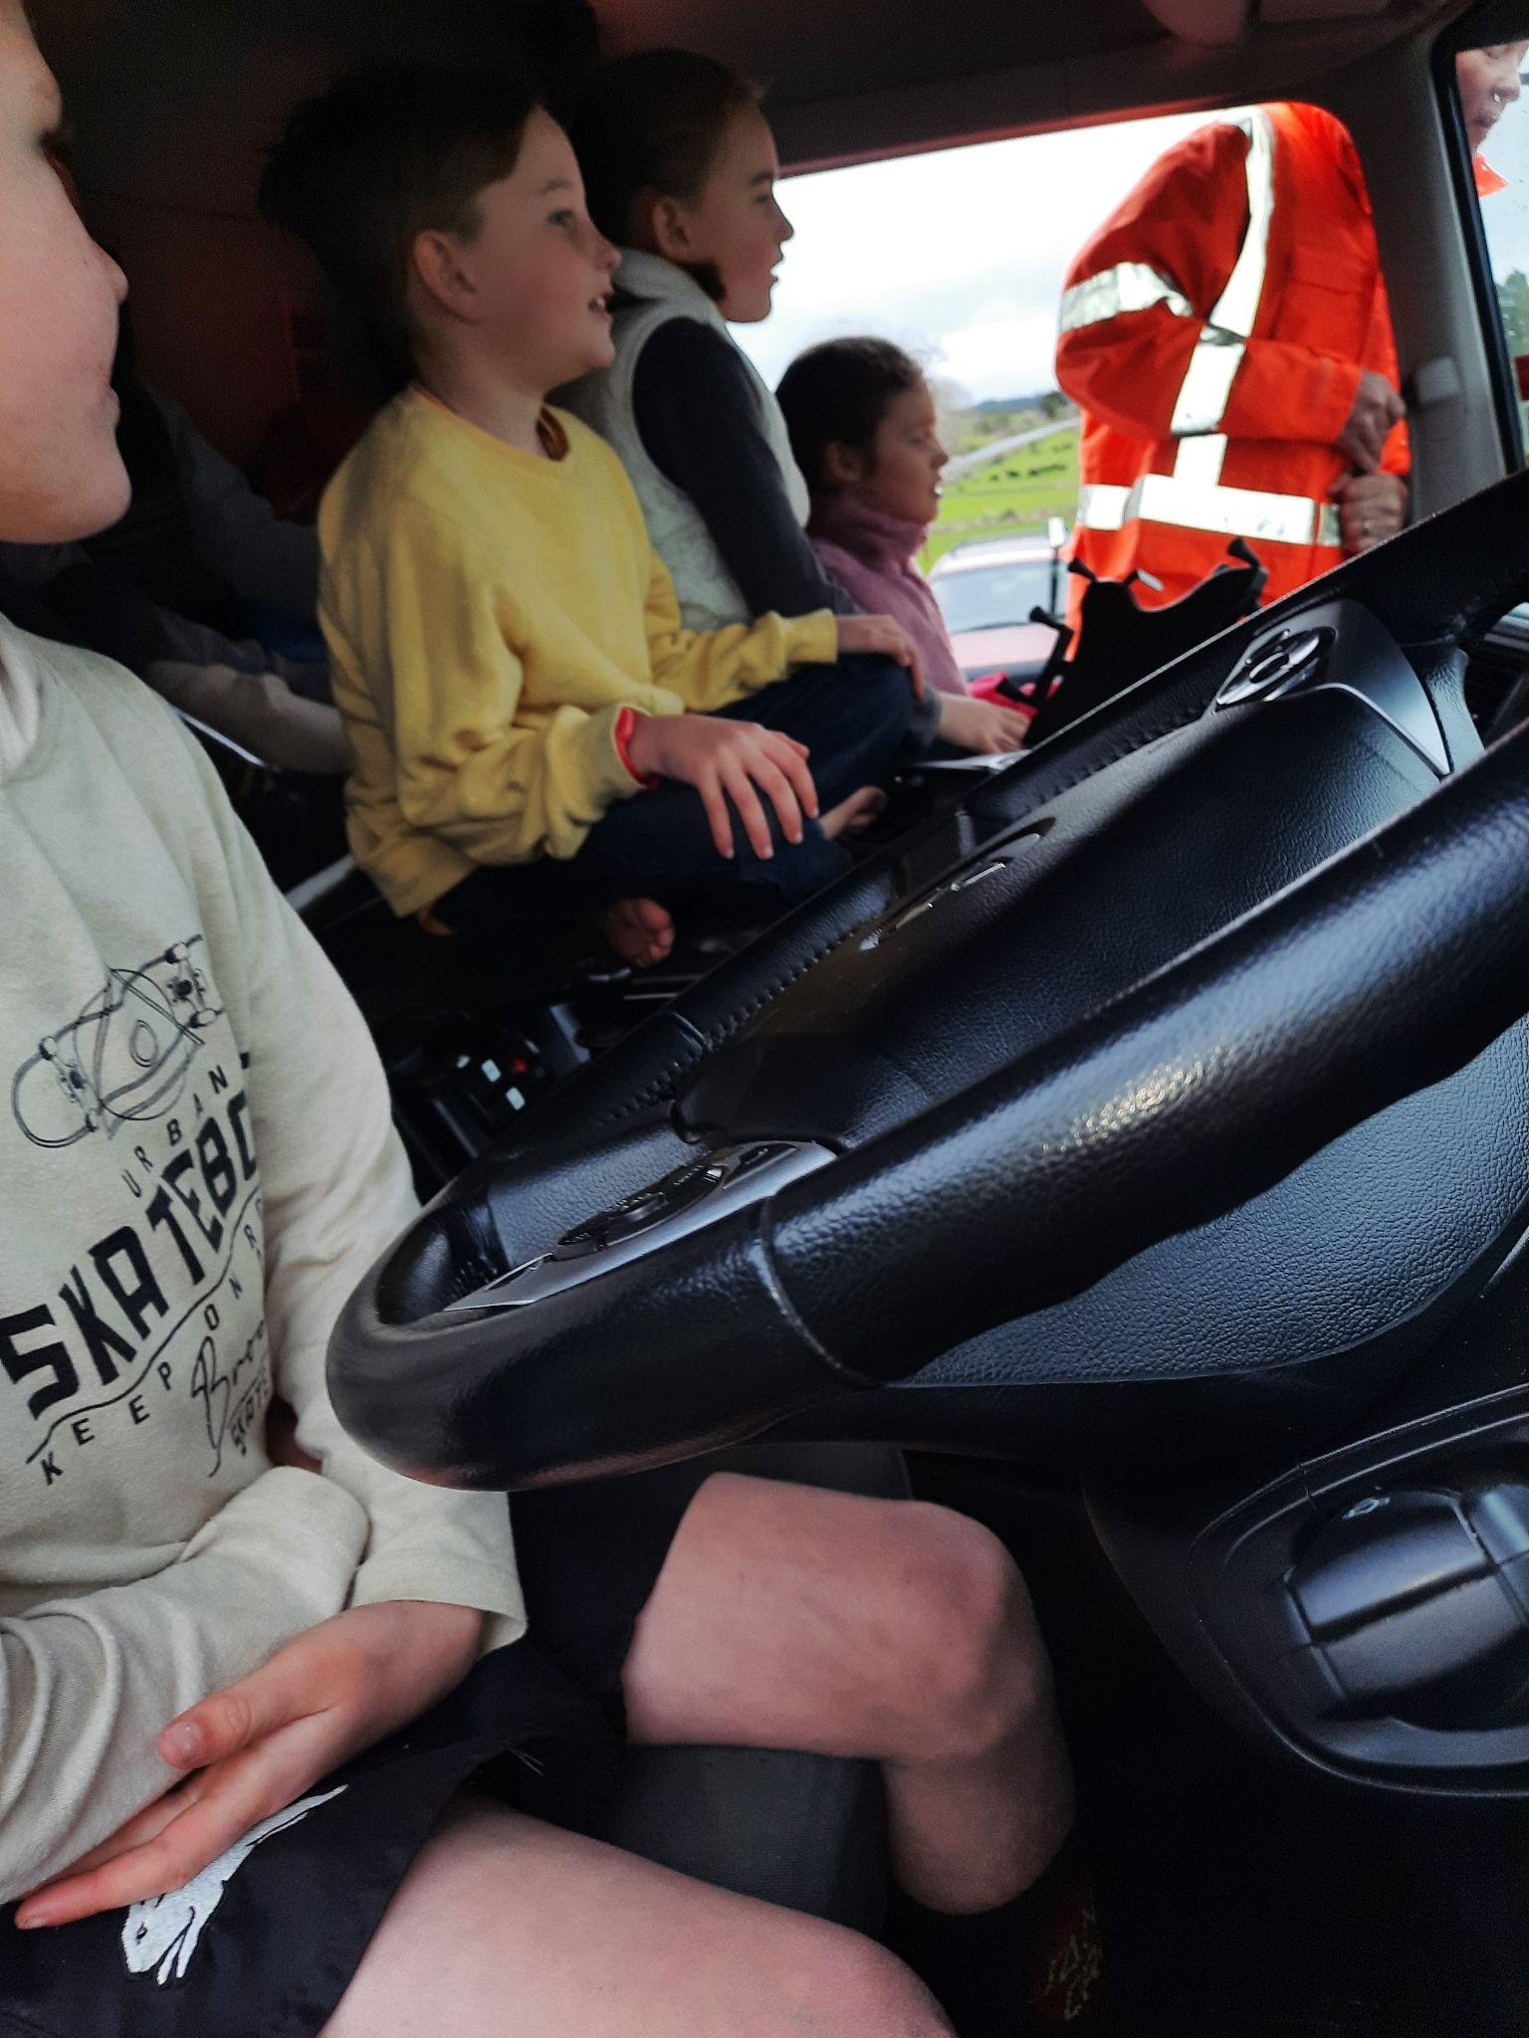

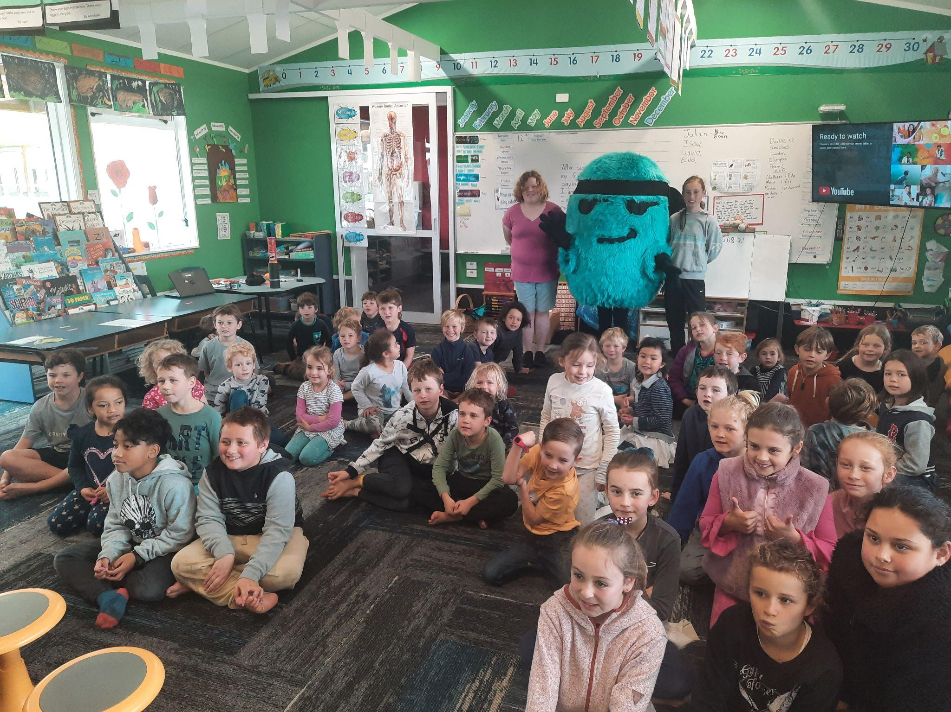

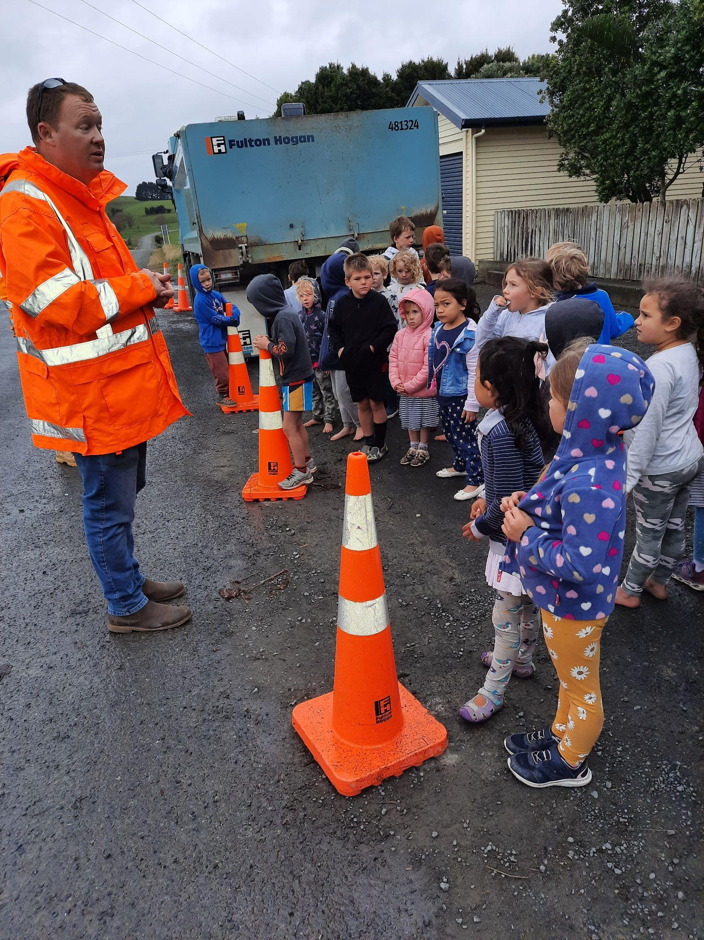

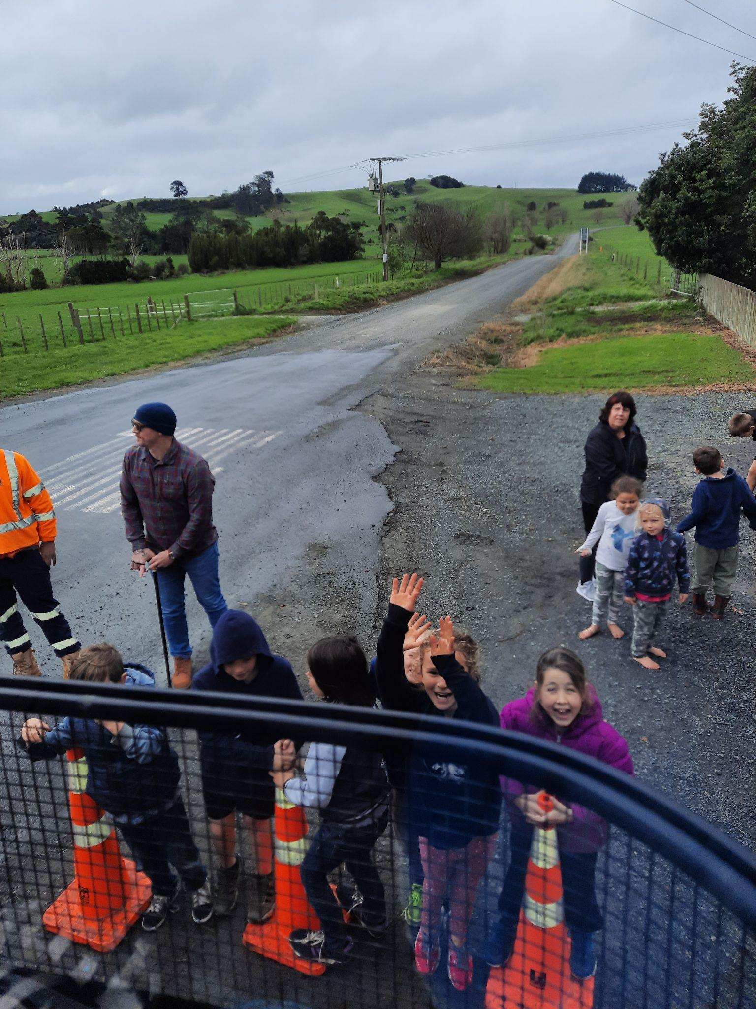

Tomarata School

Local Curriculum Plan:

Leadership-

Developing Leadership Skills

* Year 8’s have the opportunity to become House Captains. They lead assemblies; do a community project for the school or community; provide leadership at sports events; meet visitors; attend a Leadership Conference
* The senior students take part in leadership units of work e.g. The Gem Project currently being done with Shane Gould
* Goal setting and reflection
* Peer group feedback/feed forward
* Cooperative learning opportunities
* GROW Values work & positive mindsets
* Organised visits from effective community role models
* Providing opportunities for experiences & challenges
* Promoting the Tomarata School Vision
* Independence fostered for College ( Tech lessons)
* Speeches
* Year 8 prize- giving

Leadership in Practise

* Tabloids sports leaders
* House leaders
* PE Shed monitors
* Flag monitors
* Bus monitors
* Organisation & running of assemblies
* Buddy classes
* Class monitors
* Student Voice reps

Student Voice Programme

* Class reps attend meetings with Mrs Sibtsen ( 2 children per class)
* Annual action plan
* Information shared- feedback & suggestions
* Involvement in projects e.g. discos; Fireworks; Ag Day
* Assistance with Good Citizen ticket draws at assemblies
* Certificates at Prize-giving

PB4L Good Citizenship

* Tickets received for living & displaying the GROW values
* Recognition & rewarding of positive actions
* Lucky Dip bucket at assembly draws & for values assemblies to receive mascots
* Certificates for good citizenship awarded at assemblies ( 1 per class)

In the classroom opportunities for selected/rotated leaders are promoted for tasks, opportunities & activities. Cooperative learning activities e.g. Maths trios give children many experiences in a variety of roles.

Just for a Giggle